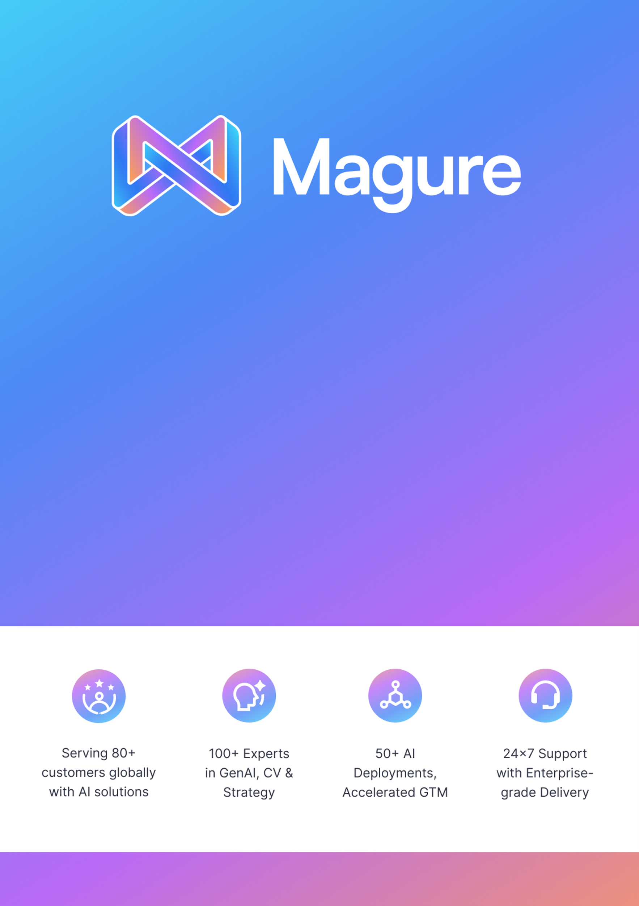

Executive Summary

Emarat is embarking on a strategic journey to leverage Artificial Intelligence (AI) as a catalyst for operational efficiency and superior stakeholder experiences. In line with Emarat’s core objectives of **reducing General & Administrative (G&A) expenses** and **enhancing both customer and employee experiences**, we have identified 25 high-impact AI use cases tailored to its business priorities.

These use cases are designed to:

* **Optimize Costs** by automating repetitive processes, streamlining workflows, and improving decision-making with data-driven insights.
* **Elevate Customer Experience** through personalization, faster service delivery, predictive engagement, and improved service quality.
* **Empower Employees** with intelligent tools that reduce manual effort, improve collaboration, and enable more meaningful, value-added work.

Once Emarat picks the relevant use cases, Magure will conduct assessments with data producers (business) and data custodians (IT) to ascertain the highest impact uses cases to pilot/productionize.

Use-cases are compiled under objectives of

1. Reducing G&A expenses for the business
2. Improving customer experience and identifying new revenue opportunities

**Business to Customer:**

**1. Footfall Tracking and Heat maps:** Measures customer visits at stores. Visual insights into customer movement patterns to identify high-engagement zones, enabling smarter promotional placements.

**2. Inventory Management**: Stock counting on shelves and sends alerts on shortage and delays.

**3. Queue Monitoring:** Help detect long queues at pumps, stores and car washes through CCTV, identifying peak hours and patterns to plan for staffing and smooth flow of vehicles.

**4. Automatic Emcan mapping:** As Emcan customers visit pumps and scan codes, map vehicles to Emcan database to use automatic reward mapping for all future visits, improving the customer experience.

**5.** **Product Bundling:** Identify services and products purchased together at pumps and retail stores to enable cross sell to Emarat customers.  
  
**6.** **Customer support**: Helps answer FAQs about promotions, points, fuels prices, car wash services. This will also help customers place and track orders.  
CS Agents are empowered with tools based on the active conversations to assist customers better, reducing call time and better manage call queues.

**7. EMcan** – Augment Emcan app with AI Chatbot for customers. To locate fuel stations, book car washes, service, find restaurants, answer customer queries etc.

**Business to Employee:-**  
  
**1. Employee support helpdesk:** Helps answer queries like leave balance, payroll, insurance coverages, grievance reporting. Helps address repetitive questions and improves response times.

**2. Time & Attendance:** Computer vision for enhanced employee attendance tracking using facial recognition, at retail stores and other locations for blue collar employees

**3. AI Powered Hiring**: Streamline hiring by pre-screening candidates for roles ranging from station attendants to engineers andadmin to logistics, ensuring fast hiring cycles and meeting Emarat’s diversity goals.

**4. Vendor Onboarding:** AI extracts key data from documents like trade license, VAT etc. validates documents and generates alerts for potentially fraudulent and incomplete information.

**5. Emarat insights:** Conversational AI that interacts with enterprise data (across ERP, POS, CRM and other systems) to give quick insights into the business, accelerating decision making

**6.** **Document Reconciliation:** AI Agents accelerate internal operational processes such as invoice generation from demand orders and reconciling vendor invoices with POs to reduce manual hours and save operating expenses.

**7. Demand forecasting**: AI Assisted demand forecasting ensures improved accuracy in projection for sales and finance teams and helps plan inventories for operations teams.

**8. Security, Safety and Compliance**: - Detect unauthorised zone entry, smoking in restricted areas, detecting staff without uniform/PPE. B2E (retail stores/pumps)  
  
**Business to Business: -**  
**1. Order taking assistant:** Simplify order taking for commercial products customers of Emarat to automatically capture orders through a simple AI interface and generate invoices from these demand orders.

**2. Fleet Vehicle Recognition:** Tracks fleet vehicles by plate at stations and delivery points and identifies if there they are idle for to long or taking too long to load/unload.

**3. Contract Review and Commercial Agreement Generation:** Language models utilize knowledge base of prior contract and agreements to generate customer documents and review contracts for potentially risky clauses.